DATA SHEET :

Name of the Product : Glucosamine Sulfate Sodium chloride USP
Chemical Name : Bis(D-Glucose,2-amino-2-deoxy-),sulfate Sodium chloride complex
Molecular Formula : (C₆H₁₄NO₅)₂SO₄.2NaCl
Molecular Weight : 573.31
CAS No. : 38899-05-7
Structure :

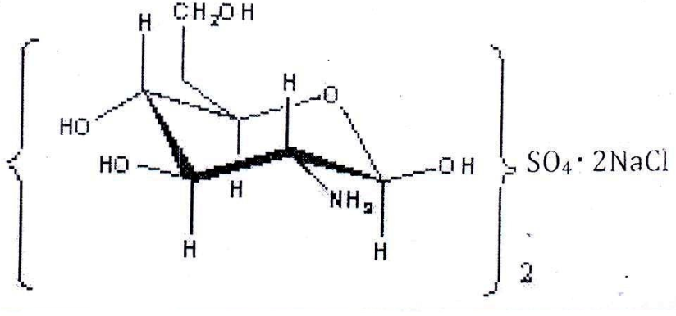

Glucosamine also called as 2-amino-2-deoxy glucose is a natural amino sugar available in chitin. Chitin is a polysaccharide found in the outer skeleton of shrimps and crabs. Chitin is extracted through the process of decalcination, deprotenation etc.

SPECIFICATION :

Name of the Product : Glucosamine Sulfate Sodium Chloride USP
Reference : USP-35

S.No. | Test | Specification
1. | Appearance | White crystalline Powder.
2. | Identification:
 | a) I.R Absorption | The IR absorption spectrum of the sample should be concordant with the reference spectrum of Glucosamine Hydrochloride WS.
 | b) Chloride & Sodium test | It meets the requirements of the tests for chloride and Sodium.
 | c) HPLC – Retention time | The Retention time of the sample assay peak corresponds to that WS peak.
 | d) Reaction of sulfate. | A white precipitate is to be formed after addition of Barium chloride TS in the test for content of sulfate.
3. | Physico- Chemical Analysis:
 | a) Solubility | Freely soluble in Water.
 | b) Loss On Drying, 2 hrs at 105⁰C ( % w/w) | NMT 1.0
 | c) Sp. Optical Rotation, 35mg/ml. (Deg). | + 50.0 to +55.0
 | d) Residue on Ignition ( % w/w) | 22.5 – 26.0
 | e) P^{H}, 2% Solution | 3.0 to 5.0
 | f) Sulfate Content (% w/w) | 16.3-17.3
 | g) Potassium | Precipitate should not be formed
 | h) Particle Size | 100 % Passing through 40/60/80/100 mesh.
4. | Arsenic ( ppm) | NMT 3.0
5. | Heavy metals (ppm) | NMT 10
6. | Assay, on dried basis (% w/w) | 98-102

